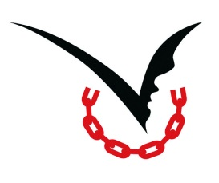
International Day of Prayer and Awareness
Against Human Trafficking

February 8 is the first International Day of Prayer and Awareness Against Human Trafficking. The two Unions of Superiors General, the Global Freedom Network, Talitha Kum, and others are making plans for celebrating in Rome. Some activities include: February 3 - Press Conference; February 6 - prayer vigil; February 8 - Mass with presider Cardinal Joao Braz de Aviz, followed by participation in the Angelus with Pope Francis in St. Peter’s Square at 12:00.
After February 2, resources will be available at www.a-light-against-human-trafficking.info. The resources will include a short prayer available in English, Italian, Portuguese, Spanish, Swahili and more; and a longer prayer service in English, Italian, Spanish, and more. This new website will be interactive, with:
1. A world map in which one can ‘turn on the light’ in countries that are observing the Day of Prayer and combating human trafficking;
2. Photos and news about prayer and efforts against trafficking;
3. St. Bakhita represented as a sign of hope and freedom from slavery;
4. Stories of hope and freedom can be submitted in any language.
We might recall Pope Francis’ Message for the World Day of Peace 2015: No longer slaves, but brothers and sisters. “We ought to recognize that we are facing a global phenomenon which exceeds the competence of any one community or country. In order to eliminate it, we need a mobilization comparable in size to that of the phenomenon itself… We know that God will ask each of us: What did you do for your brother (or your sister)? (cf. Gen 4:9-10). The globalization of indifference, which today burdens the lives of so many of our brothers and sisters, requires all of us to forge a new worldwide solidarity and fraternity capable of giving them new hope and helping them to advance with courage amid the problems of our time and the new horizons which they disclose and which God places in our hands.”
Let us encourage participation in prayer, awareness-raising events, and other actions in our local communities, parishes, dioceses, and countries.

Roxanne

